|  |  |
| --- | --- |
| Journal of  African  Christian  Biography | **Vol. 7, No. 2/3 (Apr-July 2022)**  **Focus**: **Anabaptist-Mennonite Movement in Africa**  DOUBLE ISSUE  BILINGUAL (ENGLISH) |

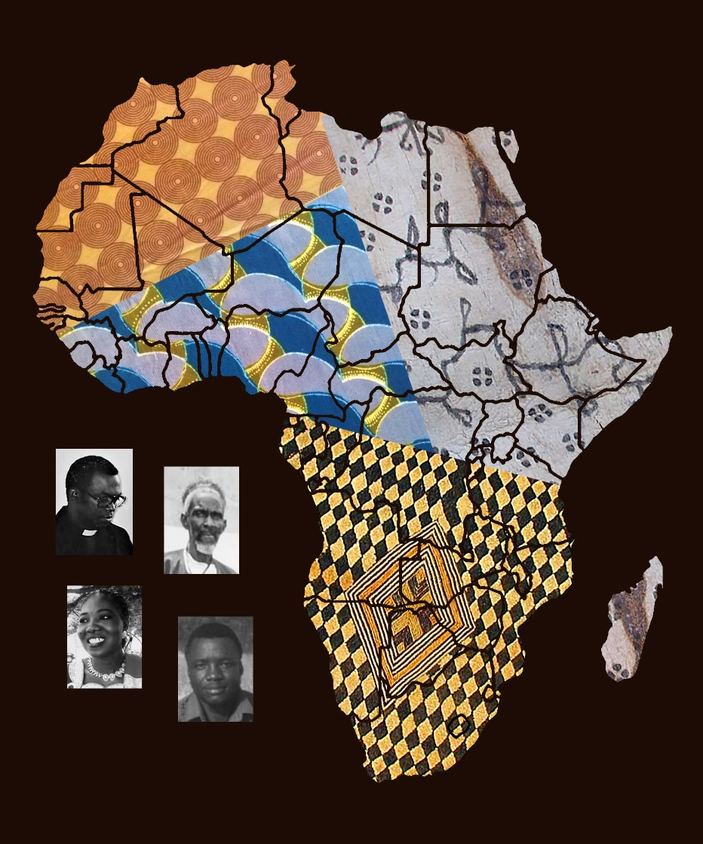  
  
A publication of the *Dictionary of African Christian Biography*